INDEX.HTML

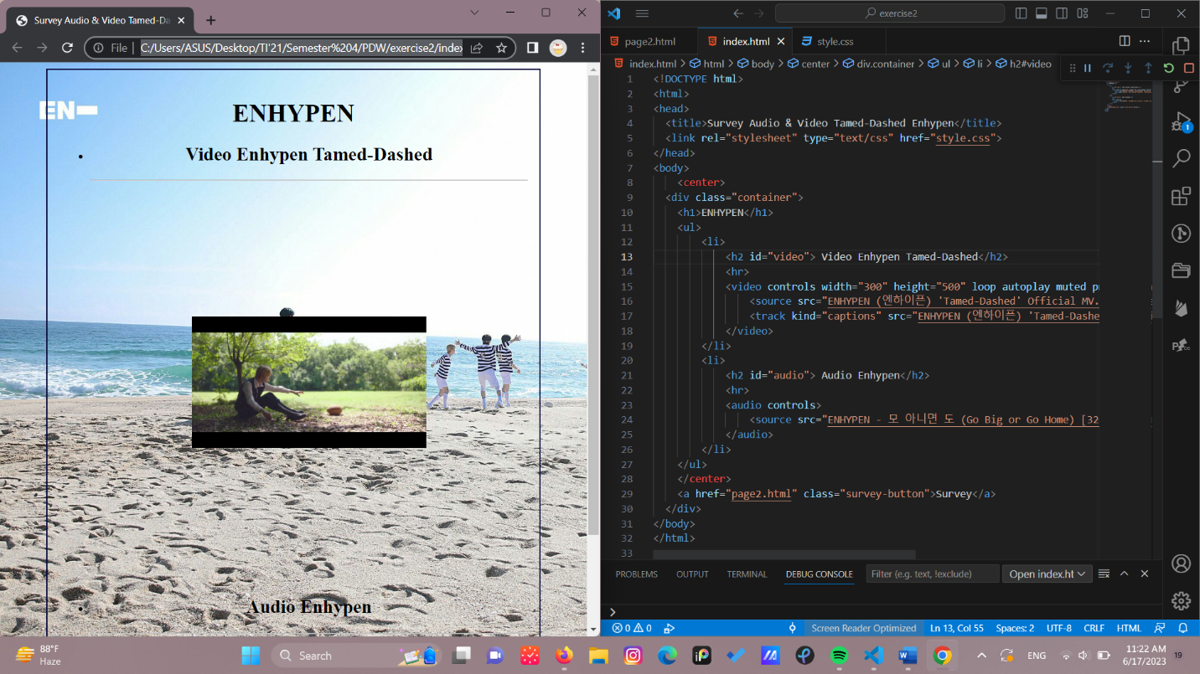

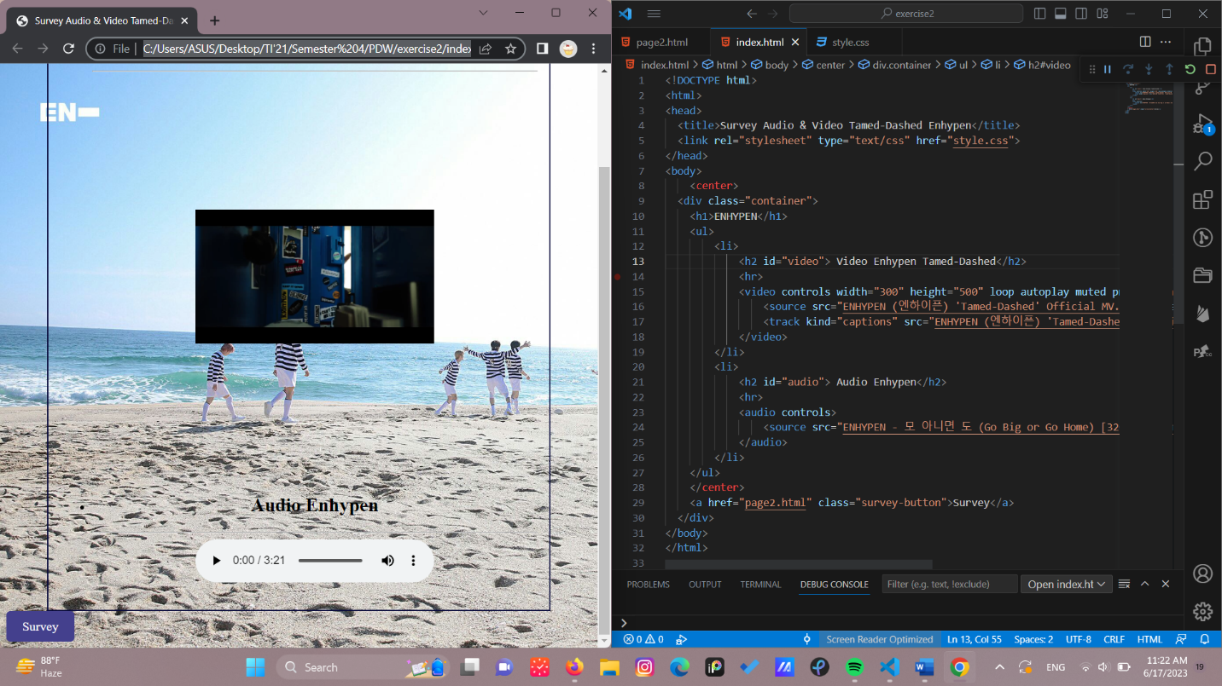

PAGE2.HTML

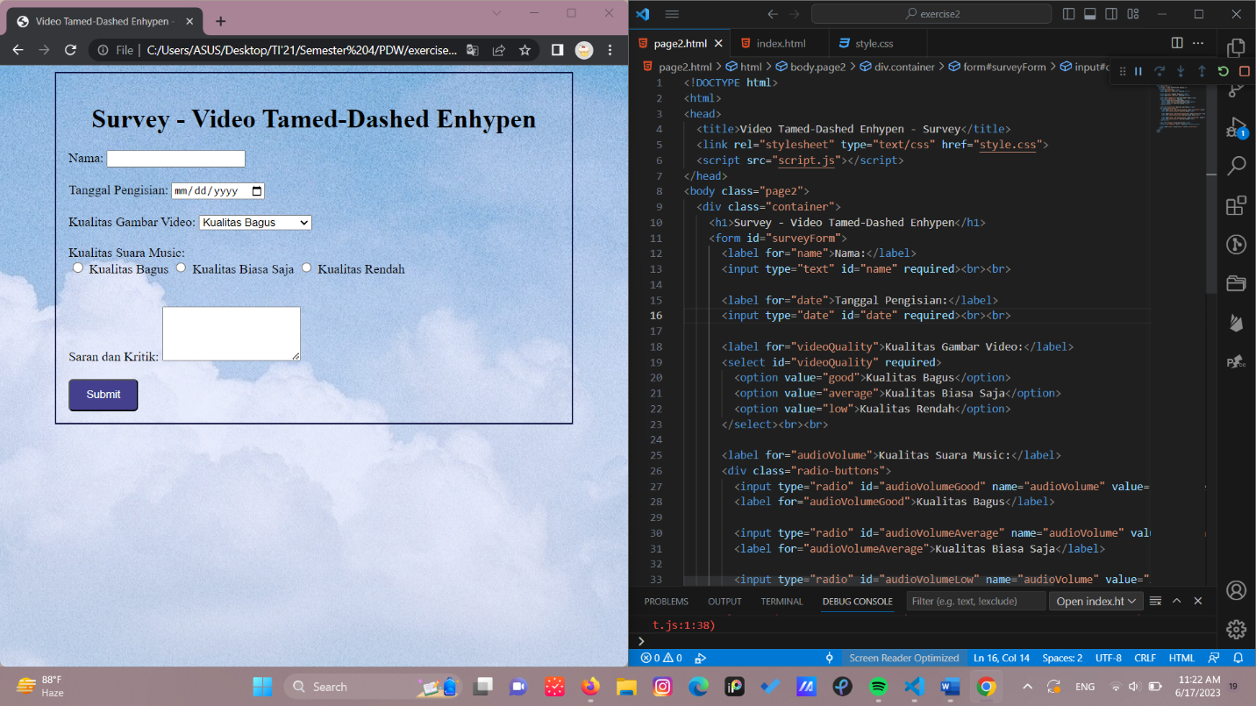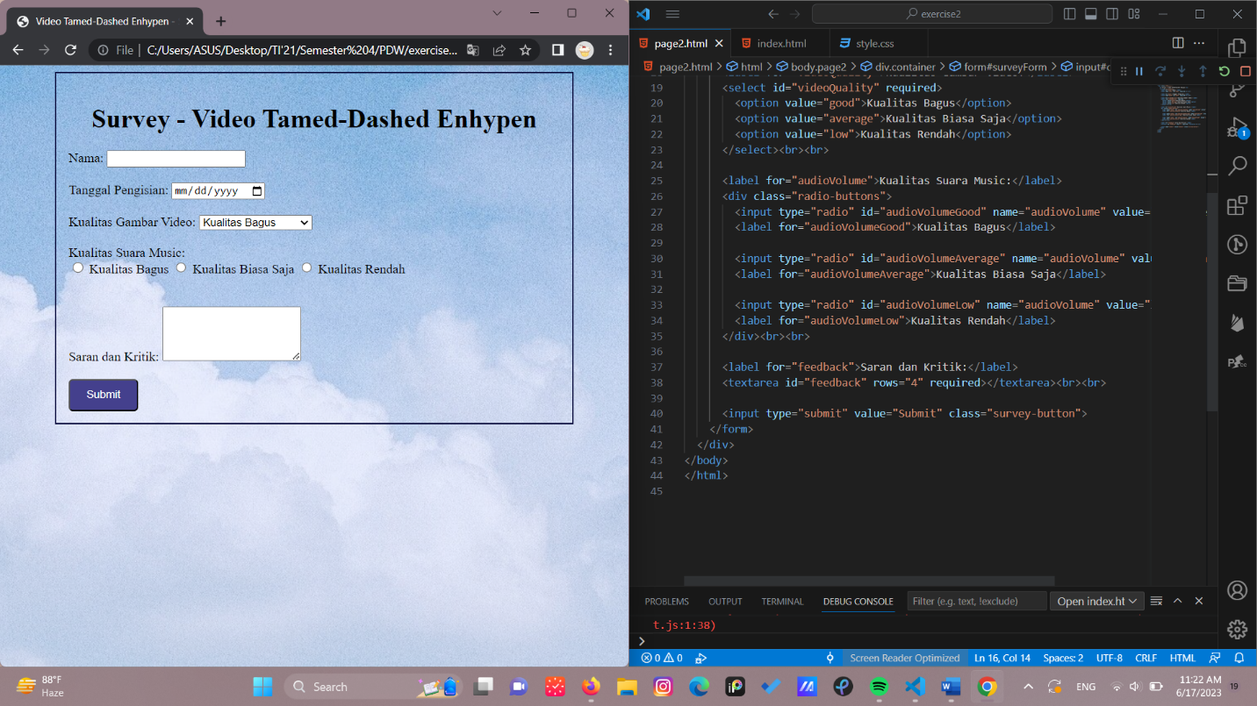

SCRIPT.JS

